RESOLUTION 2018-011

WHEREAS, the Town of Olla needs to replace its Wastewater Treatment Plant whose AI #1 9346; and

WHEREAS, loans and/or grants for this project may be available through the State Revolving Fund loan program operated by the Louisiana Department of Environmental Quality:

NOW, THEREFORE, BE IT RESOLVED, by the Town Council of the Town ofOila that:

Section 1 . Rhonda Elliott, Mayor, is hereby authorized to submit a pre­ application, application and issue debt in the amount of$1,690,000.00 to the Department of Environmental Quality on behalf of the Town of Olla for the purpose of placing this project on the Comprehensive Priority List for funding through the State Revolving Loan Fund program; and,

Section 2. Rhonda Elliott, Mayor is further authorized to furnish such additional information as may reasonably be requested in connection with the pre-
application; and,

Section 3. The Mayor is hereby designated as the Official Project Representative for the Town of Olla for any project that may result from the submission of the
pre-application.

A MOTION TO ADOPT the above resolution was made by Fenoli, seconded by Bailey, and resulted in the following vote:

YEAS: 4

NAYS: 0

ABSENT: ABSTAINING: 0

CERTIFICATE

We the undersigned do certify that the foregoing resolution is a true and correct copy of a resolution adopted at a meeting held on the 13th day of November, 2018, at which meeting a quorum was present and voting.

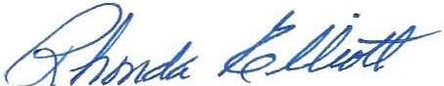

ATTEST:
RHONDA ELUOTT, MAYOR

